Nama : Putra Dwi Kurniawan

Nim : 22.01.53.3014

<http://localhost:8080/webdatabase/api.php/records/customers>

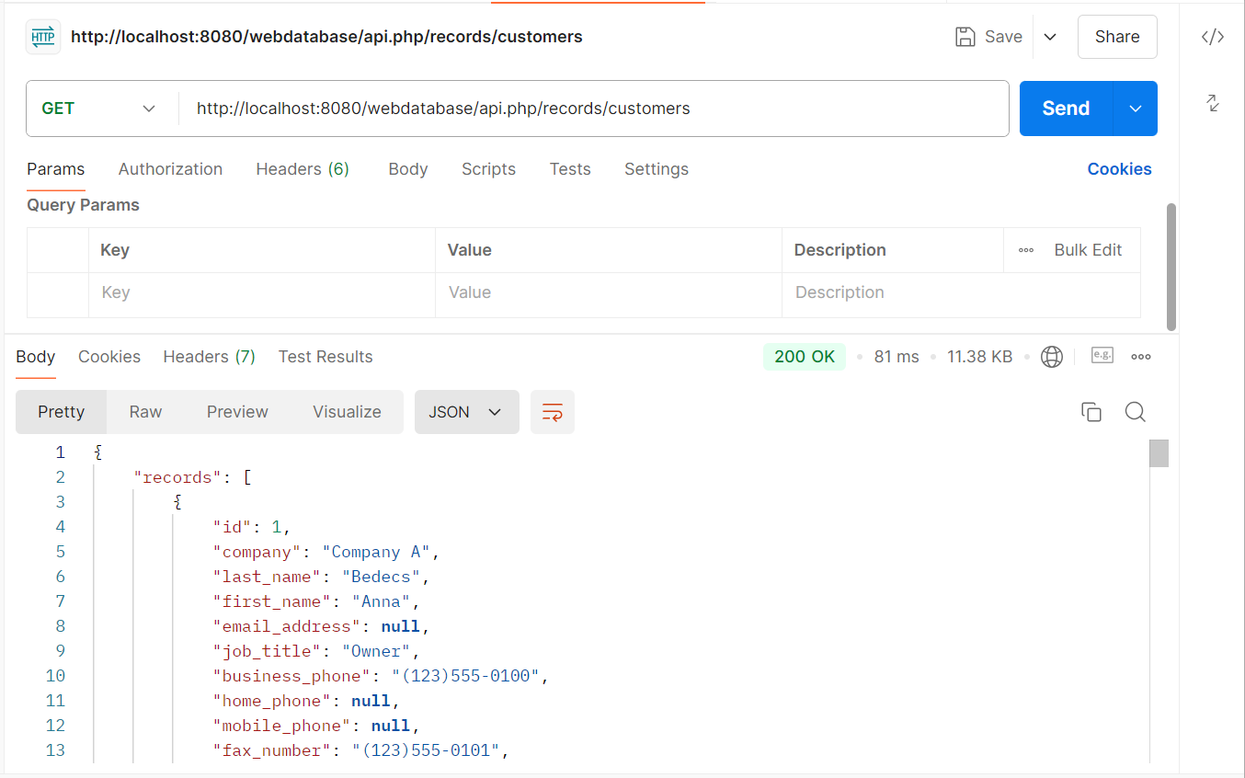

http://localhost:8080/webdatabase/api.php/records/orders